Knowsim: A document similarity measure on structured heterogeneous information networks
- Model: KnowSim
  - Purpose: unsupervised document similarity, automatic way to generate meta-paths
  - Knowledge Base: FreeBase
  - Steps:
    - Meta path dependent PageRank Nibble: locally partition HIN based on metapath, approximate commuting matrices
    - Store commuting matrices
    - Meta-path selection based on feature selection (minimum spanning trees, Laplacian scores)
  - HIN of: 100k entities, 9.6 million relations
- Constructing Document HIN
  - Semantic parser to generate doc semantic meaning (another paper)
    - Output: document w/ entity types and relation types
  - Link documents via meta-paths
    - Computed via commuting matrix
    - For practicality
      - Prune network for matrices
      - Unsupervised feature selection of meta-paths
- Meta-path Calculation
  - Metapaths at first? Random generate then choose symmetric
  - Steps Overview
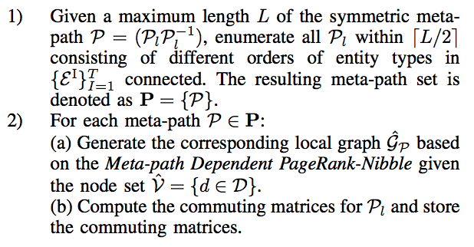
  - PageRank Nibble algorithm for random walk approx to HIN
    - Goal: to find small, low-conductance component of a graph (to prune)
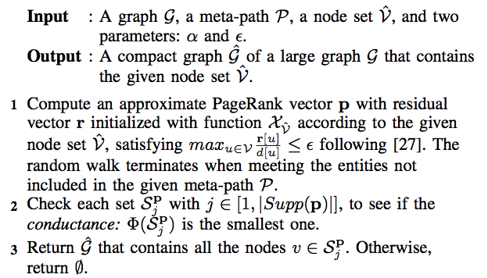

  - Generate commuting matrix for each symmetric meta-path in local graph
    - Want symmetric to decompose
- HIN-Based Document Similarity
  - MetaPath Selection
    - Tensor to encode numbers of meta-paths
      - Three dimensional matrix
    - Document meta-path representation matrix
      - On meta-path density
    - Maximal Spanning Tree Selection
    - Laplacian Score based selection
  - Knowledge-Driven Document Similarity (on selected most important meta paths)
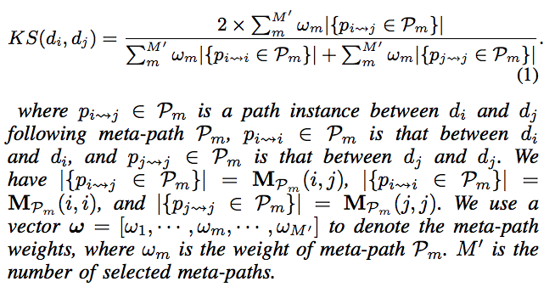

Text Classification with Heterogeneous Information Network Kernels
- Overview
  - Text as HIN b/w different documents
    - Meta-paths to link texts
  - Structured and typed info of entities and relations → kernels (simple linear and indefinite)
    - Simple: link based augmentation of text
    - Indefinite: Weighted meta-path similarity using SVM
- Link Based Linear Kernel
  - Text Classification
    - Semantic parsing then semantic filtering (done in prev. paper)
    - Then haven HIN text network: of text D, word W, named entities, relation types that connect
    - BOW for each entity
      - And number of metapath instances as features b/w documents
    - Naive Bayes or SVM
  - Indefinite HIN-Kernel SVM
    - Knowsim (above paper)
    - SVM w/ Indefinite Kernel
      - Knowsim matrix not PSD
      - Use min-max theorem (another paper) to learn a PSD matrix
      - Differentiability of objective function
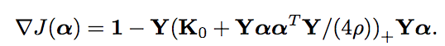
Learning with Local and Global Consistency
- Purpose: iterative algorithm for building smooth classifying function; each point iteratively spreads label info to its neighbors until a global stable state is achieved
- Algorithm
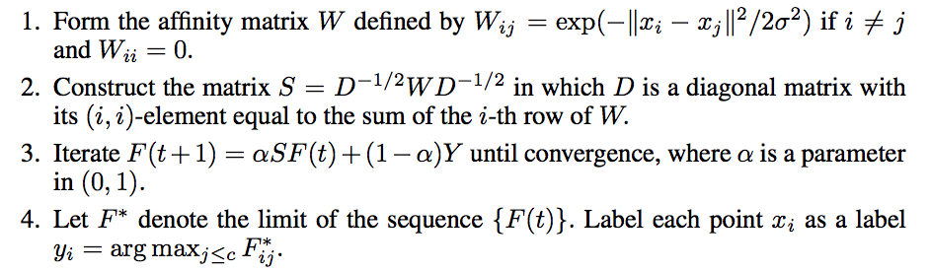
- Regularization Framework
